

**ULRS1032 INTEGRITY AND ANTI-CORRUPTION**

**SECTION10**

**MODULE 2**

GROUP ASSIGNMENT

GROUP 7

GROUP MEMBER:

| GROUP MEMBER | NO MATRIC |
| --- | --- |
| NUR ALYA NAJWA BINTI NORHAFES | A23KT0281 |
| LAW ZI HEN | A23KT0272 |
| LIM YU HAN | A23CS0241 |
| TEH RU QIAN | A23CS0191 |

**TABLE OF CONTENTS**

1. Introduction …………………………………………………………………………..2
2. Literature Review……………………………………………………………………..4
3. Methodology ………………………………………………………………………….6
4. Result and Discussion ..………………………………………………………………8
5. Suggestion and Conclusion ………………………………………………………… 12
6. List of References ……………………………………………………………………14

**1.0 Introduction**

* Background of the current issue

**Five enforcement officers were among ten detained by MACC for accepting an RM600,000 bribe.**

The Malaysian Anti-Corruption Commission (MACC) in Sarawak has apprehended 10 individuals, including five enforcement officers, on charges of accepting a bribe of approximately RM600,000. The suspects are accused of refraining from acting against illicit gambling activities in Sarawak in exchange for the bribes. The operation took place from 4 p.m. to 11 p.m. on September 11, 2023, in Sibu and Kuching. All 10 individuals aged between 20 and 40, are believed to have committed the offense since 2019. Following the arrests, the suspects were presented for a remand application at the Kuching Magistrate's Court at 9 a.m. September 12, 2023. Magistrate Mason Jaro Lenya Barayan issued a four-day remand order until September 16, 2023. Sarawak MACC Director Datuk Zaki Hassan stated that the case is being investigated under Section 17 (a) of the MACC Act 2009.

* Chronology of the issues

Allegations of illicit gambling activities in Sarawak prompt an investigation by the Sarawak Malaysian Anti-Corruption Commission (MACC). The Sarawak MACC conducted an operation in Sibu and Kuching from 4 p.m. to 11 p.m. on September 11, 2023, resulting in the detention of ten individuals, including five enforcement officers.

The detained individuals are accused of accepting bribes to oversee illegal gambling operations. The suspects allegedly received around RM600,000 from five individuals, acting as protection for the illicit gambling activities. Shockingly, it is disclosed that the enforcement officers involved have been engaging in corrupt practices since 2019, underscoring the prolonged duration of their misconduct.

The arrested individuals are brought before the Kuching magistrate's court at 9 a.m. September 12. 2023 for a remand application. Magistrate Mason Jaro Lenya Barayan authorizes a four-day remand, extending until September 16, to facilitate investigations and evidence gathering.

The investigation falls under Section 17(a) of the MACC Act 2009, specifically addressing corruption offenses related to public servants receiving bribes. Sarawak MACC Director Datuk Zaki Hassan confirms the arrests in response to inquiries.

* Critical Incident

The root of the issues in Sarawak's illicit gambling case lies in the alleged acceptance of bribes by enforcement officers. These officers, entrusted with upholding the law, compromised their integrity by turning a blind eye to illegal gambling activities in exchange for substantial bribes. This misconduct, reported to have begun in 2019, reflects a systemic problem where individuals in positions of authority engage in corrupt practices. The deeper issue involves a lack of ethical conduct, transparency, and accountability within law enforcement, creating an environment conducive to corruption. Efforts to address the root cause should focus on instilling a culture that discourages corruption and promotes honesty among public officials, emphasizing the importance of upholding the law and maintaining public trust.

* Objective of the case study

The objective of this case is to find the factors that led to enforcement officers accepting bribes and refraining from acting against illegal gambling activities. Furthermore, outlines the necessary steps to stop corruption from happening among enforcement officers. Additionally, identify the importance of swift and decisive action by authorities in combating corruption and upholding integrity within law enforcement agencies.

**2.0 Literature Review**

* Concept of integrity

Based on the Cambridge Dictionary, the meaning of integrity is the quality of being honest and having strong moral principles that you refuse to change. Ways to be integrity? Be honest, always tell the truth in all situations, and stop lying or cheating. In daily life, we could show it, for instance, by returning a priceless lost item we found on the street or telling a cashier we had extra change.

When it comes to ethics, someone is said to have integrity if they act by a set of internally consistent principles. These basic principles ought to be constantly guided by reasonable rules or logical hypotheses. When an individual adheres to a coherent core set of values, and their actions, attitudes, practices, standards, and beliefs all make sense, they are seen as morally upright. Because of this, one needs to be flexible and open to change when these values are called into question, such as when a predicted consequence does not match all observation results, to maintain consistency. Being a form of accountability, such flexibility is regarded as both an ethical duty and a virtue.

* Concept of Corruption

            Corruption is a type of dishonesty, or a criminal offense committed by a person or organization in a position of authority to obtain unlawful benefits or abuse power for personal gain. Corruption can encompass a wide range of actions, such as influence peddling, bribery, embezzlement, and even actions that are permitted in many nations. When a public servant or other office holder uses their position of authority for personal benefit, it is known as political corruption.

Both crime and corruption are common societal phenomena that occur regularly in almost every country in the world to varied degrees and sizes. Recent evidence points to an increase in corruption. Every country sets aside money from its resources to combat corruption, regulate it, and discourage crime. The broad phrase "anti-corruption" is frequently used to summarize strategies implemented to combat corruption. Furthermore, there is a defined goal in international programs such as the United Nations Sustainable Development Goal 16 that aims to significantly eradicate corruption in all of its forms.

* Comparison of Integrity and Corruption Issues in Malaysia and Internationally

Malaysia received a score of 47 out of 180 countries on Transparency International's 2022 Corruption Perceptions Index, which ranges from 0 ("highly corrupt") to 100 ("very clean").[[1]](https://www.transparency.org/en/countries/malaysia) [[2]](https://www.transparency.org/en/cpi/2022)Based on a point system, Malaysia came in at number 61 out of 180 countries in the Index. The top-ranked nation is thought to have the most honest public sector. Concerning global scores, the average score was 43, the lowest score was 12 (ranked 180), and the highest score was 90 (ranked 1). In terms of regional scores, the Asia Pacific countries had an average score of 45, the lowest score of 17, and the highest score of 87. Since reaching a peak of 53 in 2018, Malaysia's score has decreased annually as of 2023.

**3.0 Methodology**

The research study was meticulously undertaken among the student cohort enrolled in ULRS1032-10, specifically the Integrity and Anti-Corruption course at the Universiti Teknologi Malaysia (UTM). The objective of the study was to gain valuable insights into the students' perspectives on corruption by engaging them in a comprehensive survey. A targeted sample of approximately 105 respondents, consisting of classmates, was carefully chosen to ensure a representative cross-section of opinions within the course. The survey methodology involved querying participants about the specific case under examination in the course, as well as probing their views on broader aspects of corruption. The collected data, drawn from the diverse responses of our peers, serves as a valuable resource for comprehending the prevailing sentiments and attitudes towards corruption among students undertaking the Integrity and Anti-Corruption curriculum at UTM. This research endeavors to contribute to a deeper understanding of how individuals within an educational context perceive and conceptualize issues related to corruption.

* Data Collection Method

To systematically gather data from the student population enrolled in ULRS1032-10, we devised an efficient data collection strategy by creating a Google Form tailored to our survey objectives. This digital survey platform provided a user-friendly interface, enabling us to design a structured questionnaire that encompassed inquiries about the case study covered in the Integrity and Anti-Corruption course, as well as broader questions related to corruption. To reach a diverse range of respondents, we strategically disseminated the Google Form link across various student groups within the academic context of UTM. The distribution process involved sharing the survey link through different communication channels, such as course-specific online forums, social media groups, and direct emails. By employing this multi-channel approach, we sought to maximize outreach and ensure representation from a wide spectrum of students. We then encouraged participants to actively engage in the survey by filling out the form, thereby contributing their unique perspectives to the research endeavor. The utilization of a digital platform like Google Forms not only facilitated seamless data collection but also streamlined the process of data management and analysis. The ease of accessibility and user-friendly nature of the survey platform likely contributed to a higher response rate, enhancing the overall reliability and validity of the collected data. Through this methodological approach, we aimed to obtain a comprehensive and diverse dataset that reflects the nuanced views and opinions of the student body regarding the case study and broader issues of corruption within the academic setting at UTM.

**4.0 Result and Discussion**

A)

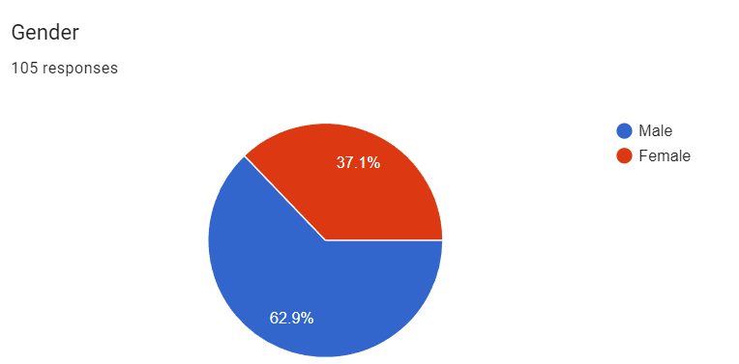

From 105 responses, there are 66 males and 39 females.

B)

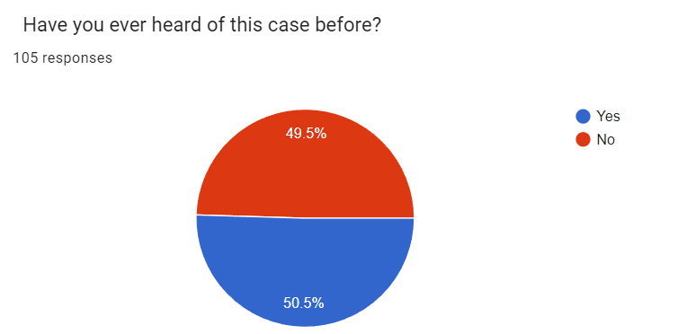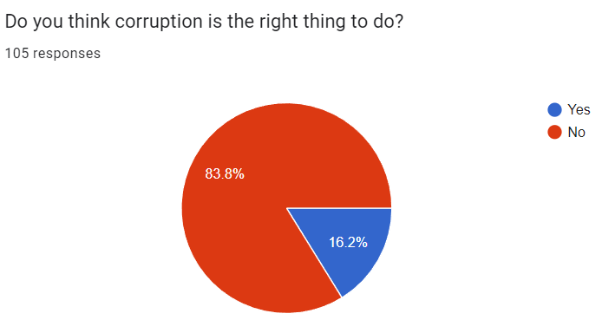

53 individuals were acquainted with this case, whereas 52 were not.

88 individuals oppose the notion that corruption is acceptable, yet 17 hold a contrary view

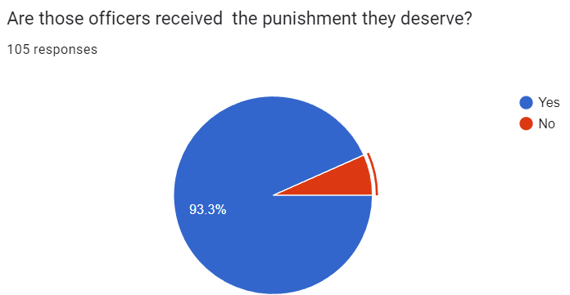

98 individuals believe that the officers deserve punishment, while 7 hold the perspective that they do not merit it.

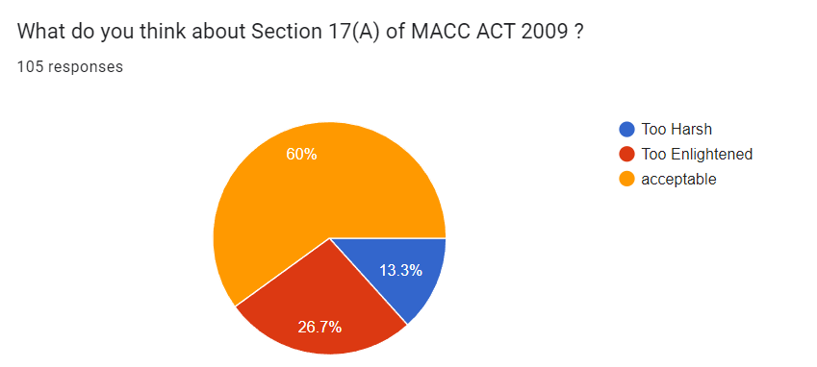

About Section 17(A) of the MACC ACT 2009, 63 individuals find the prescribed punishment acceptable, 28 consider it too lenient, and 14 believe it to be excessively harsh.

C)

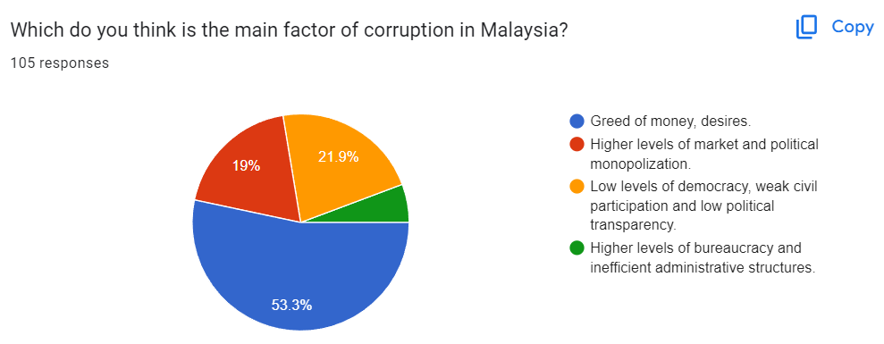

Several factors contribute to corruption in Malaysia, as indicated by our respondents. 56 individuals attribute it to the greed for money and desires, 23 points to low levels of democracy, weak civil participation, and low political transparency, 20 cite higher levels of market and political monopolization, while 6 identify higher levels of bureaucracy and inefficient administrative structures as the primary factors.

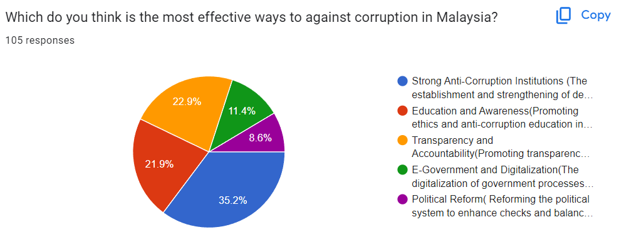

Various strategies have been identified by respondents as effective measures to combat corruption in Malaysia. 37 individuals believe that establishing and strengthening dedicated anti-corruption agencies, such as the Malaysian Anti-Corruption Commission (MACC), is crucial. Another 24 individuals consider promoting transparency in government operations, public procurement, and resource allocation as the most effective approach. Additionally, 23 respondents emphasize the importance of promoting ethics and anti-corruption education in schools, universities, and society at large to foster a culture of integrity. 12 individuals advocate for the digitalization of government processes to minimize face-to-face interactions and opportunities for bribery. Finally, 9 respondents see political system reform, including enhancing checks and balances, improving campaign financing regulations, and reducing the influence of money in politics, as a keyway to addressing political corruption.

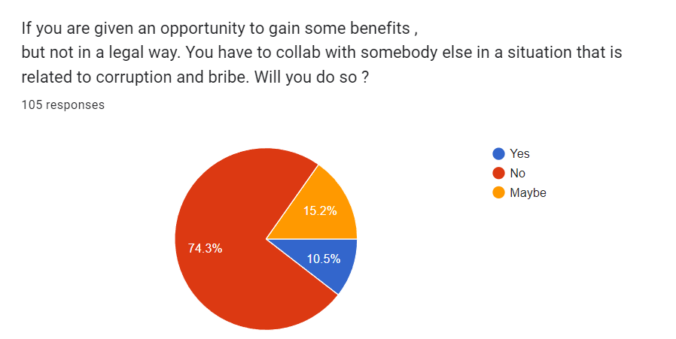

When presented with the opportunity to gain benefits by engaging in bribery, 78 individuals opted to abstain from involvement, 16 individuals expressed a willingness to consider it, and 11 individuals indicated a readiness to participate in bribery.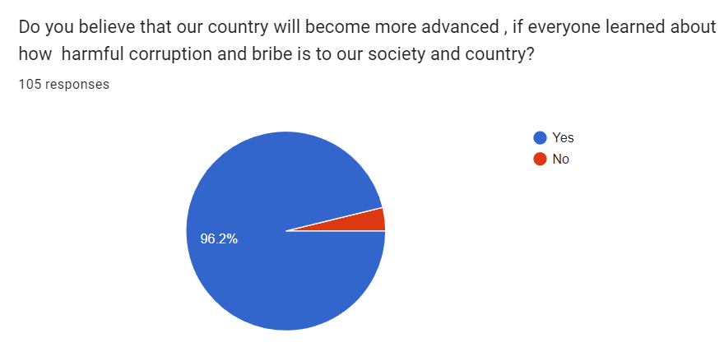

101 individuals hold the belief that our country would progress further if everyone gained awareness about the detrimental effects of corruption and bribery on our society and nation, while 4 individuals express disagreement with this perspective.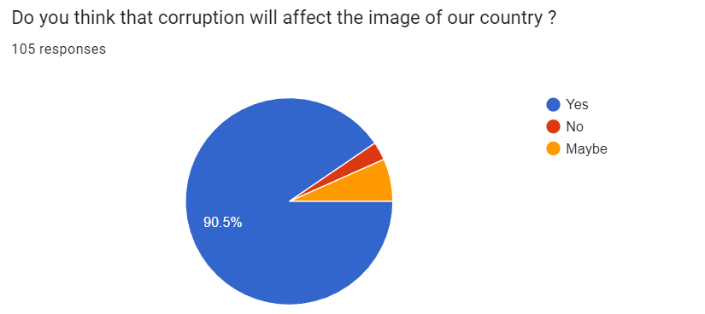

95 individuals believe that corruption will adversely impact the image of our country, 7 individuals think that corruption may have some effect on the country's image, and 3 individuals maintain that corruption will not influence the image of our country.

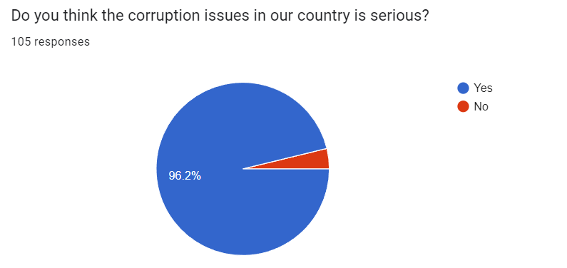

101 individuals perceive corruption issues in our country as serious, while 4 individuals hold a contrary view.

**5.0 Suggestion and Conclusion**

* Suggestions

First and foremost, conduct a tiered or level-by-level examination interview process and check their background before hiring officers. In this method, the hiring process is divided into levels, each comprising interviews and assessments that become progressively more detailed. Initial stages may focus on general qualifications and interpersonal skills, while advanced stages assess specific abilities crucial for law enforcement. These assessments include evaluating problem-solving skills, situational judgment, ethical decision-making, and physical fitness. The tiered approach ensures that only the most qualified candidates progress, streamlining the selection process and allowing for a focused evaluation.

Other than that, training officers is a crucial component in the effort to reduce corruption within law enforcement agencies. Training programs should clearly explain the serious consequences of corrupt behavior. Officers should be taught about the significance of their role in upholding public trust. This understanding reinforces the responsibility they carry and the potential harm caused by betraying that trust. For example, scenario-based training allows officers to navigate situations where ethical decisions are required. This hands-on approach helps them develop practical skills for making ethical choices in the field.

Besides, paying law enforcement fairly reduces the temptation of corrupt practices. It instills a sense of pride and value in the profession among officers. When individuals feel that their work is recognized and rewarded, they are more likely to uphold the high ethical standards expected in law enforcement. Adequate pay also plays a role in attracting and retaining talented individuals. Competitive salaries not only draw in individuals with a strong sense of integrity but also contribute to the overall professionalism of the force. Satisfied officers are more likely to focus on their duties, maintain a positive work ethic, and resist engaging in corrupt behavior.

* Conclusion

In summary, these case shows that the authorities are serious about fighting corruption and keeping law enforcement honest. By taking legal action against those accused of taking bribes, they're making it clear that corruption won't be allowed. The ongoing investigation and legal process are important to make sure the people involved are held accountable. The outcome of this case will not only affect those individuals but also influence how much people trust law enforcement. If the case is handled well, it will show that wrongdoing has consequences, making people believe in the fairness of the legal system and the commitment to keeping law enforcement agencies honest. It's a chance for the legal system to prove it can effectively deal with corruption, maintain justice, and build confidence in the community.

**6.0 List of References**

1. Transparency International. (2019, November 25). *Malaysia*. Transparency.org. <https://www.transparency.org/en/countries/malaysia>
2. Transparency International. (2023, July 14). *2022 Corruption Perceptions Index: Explore the results*. Transparency.org.

<https://www.transparency.org/en/cpi/2022>

1. ArcelorMittal Corporate Legal. (April 2016). Group Compliance and Company Secretariat.

<https://storagearcelormittalprod.blob.core.windows.net/media/nonhdquf/principles-of-integrity-explanatory-brochure.pdf>

1. The Causes of Police Corruption and Working towards Prevention in Conflict-Stricken States. (2022, August 30). Department of Humanities and Social Sciences, Teesside University, Middlesbrough.

<https://www.mdpi.com/2075-471X/11/5/69>

1. 10 Ways to Reduce Bribery & Corruption Risks. (2023, March 21). Vivek Dott.

<https://www.skillcast.com/blog/reduce-bribery-corruption-risks>